Newton’s Third Law
Part A
Investigate the forces and motion of three different systems, diagram or model the forces in those systems, and describe the pattern that you see.

System 1: Space Shuttle Launch
Watch the video of the space shuttle launch. In this system, there is a collision between the hot gases coming out of the fuel tanks and the ground or the air around the space shuttle. When you answer the questions below, focus on the forces and motion involved in that collision only.
- The hot gases escaping from the fuel tanks are forcing against the ground or the air around the space shuttle. Which direction is the force created by the gases? | - In the system model below, draw an arrow showing the direction of the force from the hot gases and an arrow showing the direction the space shuttle moved. (Use a different color for each arrow.)
- Which direction does the space shuttle move?

System 2: Swimming
Watch the video clip of Michael Phelps swimming. In this system, there is a collision between Michael Phelps’ hand and the water. When you answer the questions below, focus on the forces and motion involved in that collision only.
- Which direction does Michael Phelps force his hand through the water? | - In the system model below, draw an arrow showing the direction of the force from Phelps’ hand and an arrow showing the direction Phelps moved. (Use a different color for each arrow.)
 | 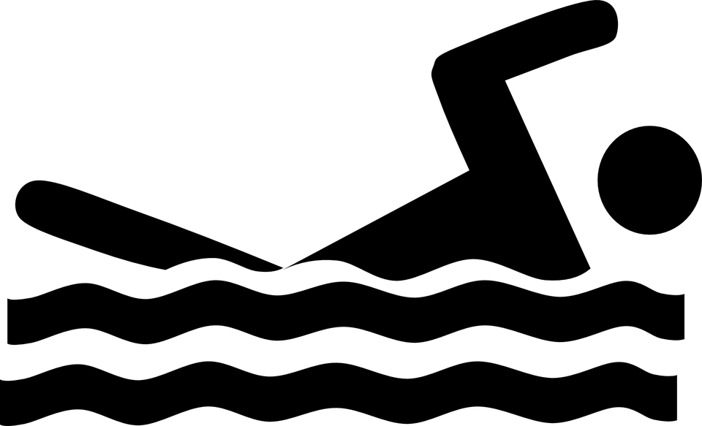
- Which direction does Michael Phelps move?

System 3: Walking
Stand up and take a few steps. As you walk, think about what is colliding in this system, the direct of the force, and the direction you move.

- What two objects are colliding in this system? | - Which object provides the force for the movement or the action force?
- In which direction is that force applied? | - Which direction did you move?
- Draw a system model of the objects that are colliding in this system. Draw an arrow showing the direction of the force and another arrow showing the direction moved. (Use a different color for each arrow.)

Part A Findings
Look back at your system models. Identify a pattern, or patterns, between the direction of the force and the direction of the motion of the object in each system. Construct an explanation using evidence from Systems 1-3.

Part B
Investigate the forces and motion of two systems, make observations, collect and analyze data, and identify a pattern.

System 4: Newton’s Cradle
Play with the Newton’s Cradle for a few moments. Lift one sphere and drop it, observe what happens. Lift two of the metal spheres at the same time, drop them, and observe what happens. Record your findings below.
- What happened when you lifted and dropped one metal sphere? | - What happened when you lifted and dropped two metal spheres?
- What pattern do you observe between force and motion while using Newton’s Cradle?

System 5: Balloon Rockets
Your teacher demonstrates how to set up a balloon rocket. Investigate the difference between using a small balloon to propel the rocket and a large balloon. Test each balloon size three times, measure the distance the rocket travels, and record it on the table. Then, find the average distance traveled by each type of balloon.

SMALL BALLOON |  | LARGE BALLOON
TRIAL | DISTANCE TRAVELED (cm) | TRIAL | DISTANCE TRAVELED (cm)
1 |  | 1
2 |  | 2
3 |  | 3
AVERAGE |  | AVERAGE

What pattern, or patterns, do you observe between force and motion with the balloon rockets? (Hint: the size of the balloon determines how much force the rocket has.)

Part B Findings
Identify a pattern between force and the motion of the object in each system. Construct an explanation using evidence from Systems 4 and 5.

Definition of Newton’s Third Law of Motion
After your class discussion, record the definition of Newton’s Third Law of Motion that your class created.

Part C
Newton’s Third Law can be used to design a solution to a problem involving the motion of colliding objects. Colliding cars is a dangerous problem that needs a solution. Seat belts and airbags are solutions that have been designed to solve the problem of how to keep a passenger safe and reduce injury when cars collide. You will watch a video of a crash test dummy in a car crash, first without safety devices and then with a seat belt and an airbag. Explain how the seat belt and the airbag use Newton’s Third Law to make the crash safer for the crash test dummy (and you).

- Watch the first half of the video clip, the crash without seat belts. Ignore the obvious collision between the car and the wall. What other collision do you see in this first half of the clip? (Hint: focus on the crash test dummy.)

- Watch the second half of the video clip, the crash with a seatbelt and airbag. Explain how each of these safety devices uses Newton’s Third Law to prevent the collision you identified above. Make sure you identify the pair of forces (the action and reaction forces) involved with each safety device.
  - The seat belt

  - The airbag

